STEPS FOR GITHUB AND OUTPUT
- git init, initializes a new Git repository in the portfolio directory. It sets up a .git folder, which allows you to track changes and version control for the project.
- git --version, checks the version of Git installed on your system. In your case, you have Git version 2.47.1.windows.2 installed.
- git remote add origin https://github.com/ramyasri-36/Portfolio-1.git:
This command links my local repository with a remote repository on GitHub
- git add, all the changes (new files, modified files, deleted files) in working directory. It prepares them to be committed to the local Git repository.
- git commit -m "initial commit", This creates a commit with a message "initial commit" in local repository. It saves the changes added in the previous step and marks a snapshot of my project at this point of time.
- git checkout -b branch-name, creates a new branch called branch-name and switches the working directory to that branch. Branches allow to work on different features or changes without affecting the main codebase.
- git push -u origin branch-name, local changes in the branch-name branch to the remote repository on GitHub.
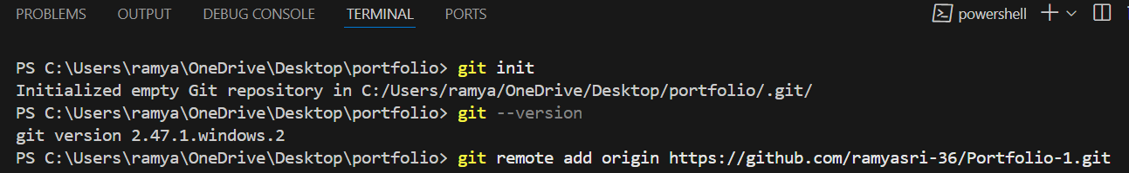

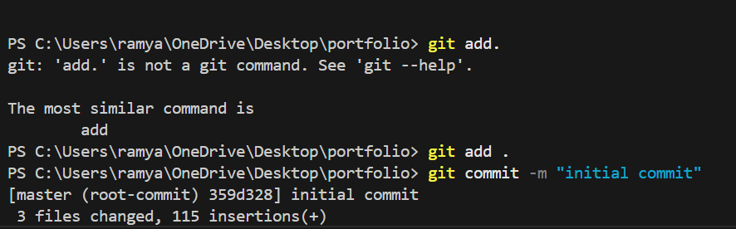

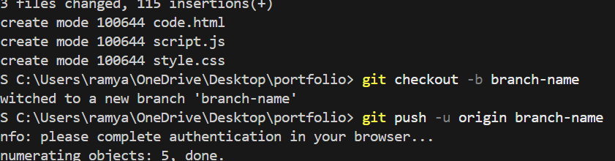

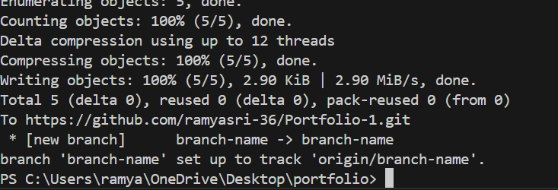

My portfolio output:

